Computer Networks

Lab 04

3/10/2021

Nadir Hussain

023-18-0025

**Lab Objectives**

* **Ping an interface from another interface using static routing**
* **Create a network of 5 interfaces using static routing**
* **Understand the routing table**
* **Create network of 5 interfaces using Dynamic routing by OSPF protocol**

**Ping an interface from another interface using static routing**

***Design the network***

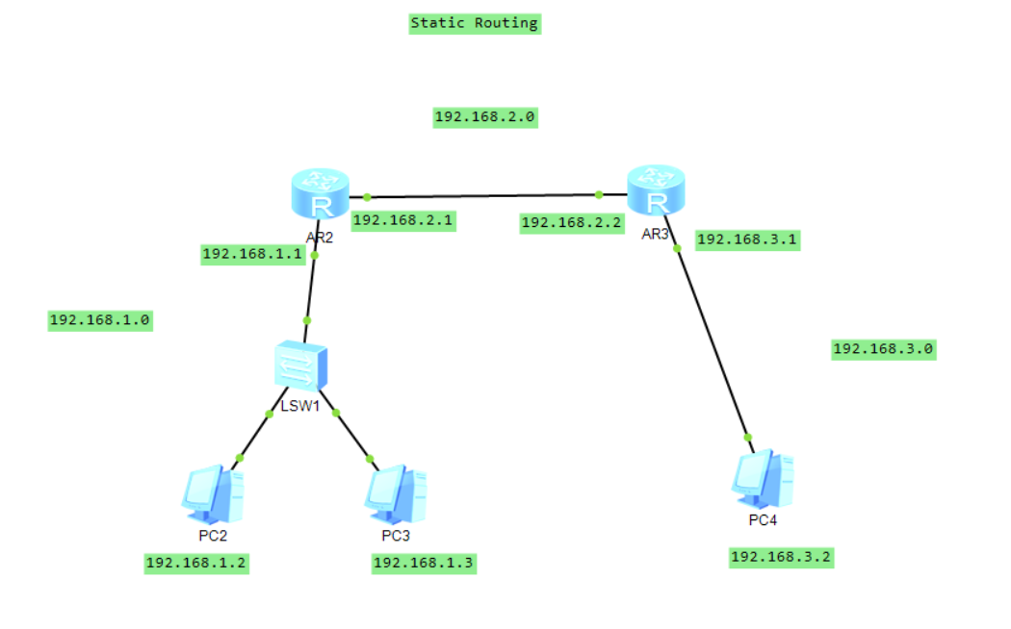

**Configure the PCs and routers**

**For router1**

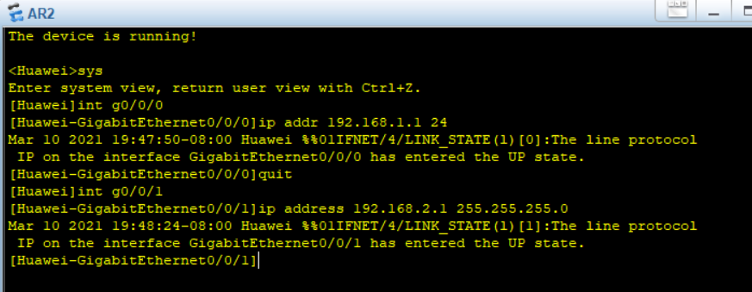

**For router2**

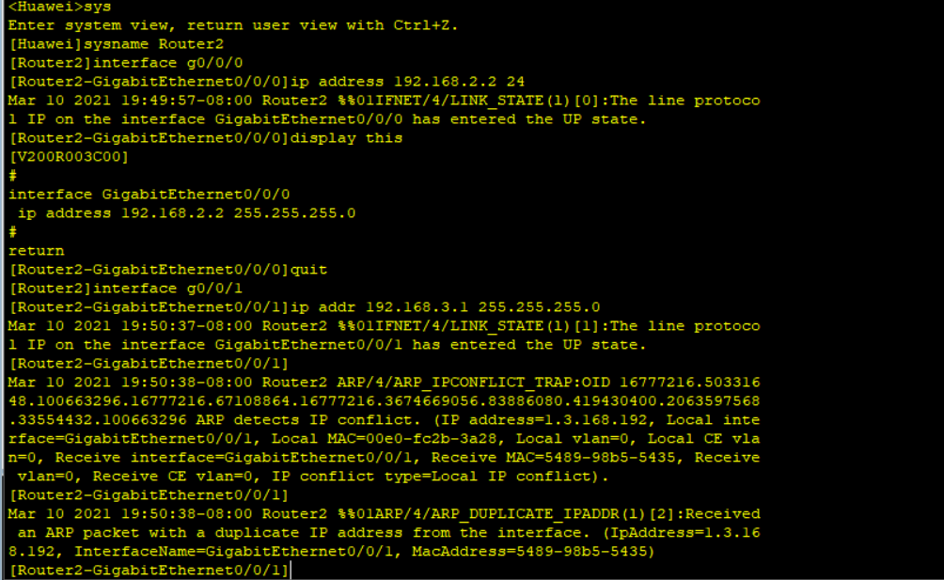

**Now we have configured Router1 and router2 and all the PCS**

**Let’s Ping from PC1 to PC2**

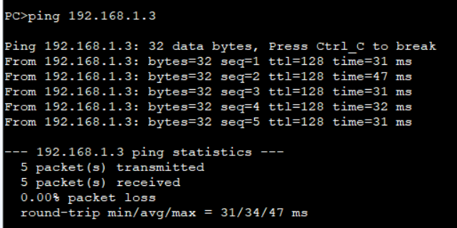

**Ping is successful from PC1 to PC2 as both are on same network**

**Let’s Ping from PC1 to PC3**

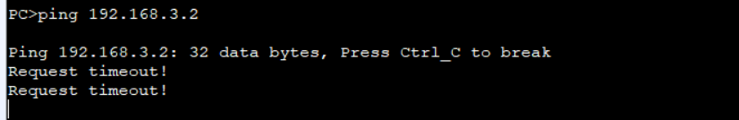

**So our networks are not connected yet.**

**We can test that PC1 can ping to 192.168.2.1 but not to 192.168.2.2**

**So we check routing table for router 1 and get information about it’s network**

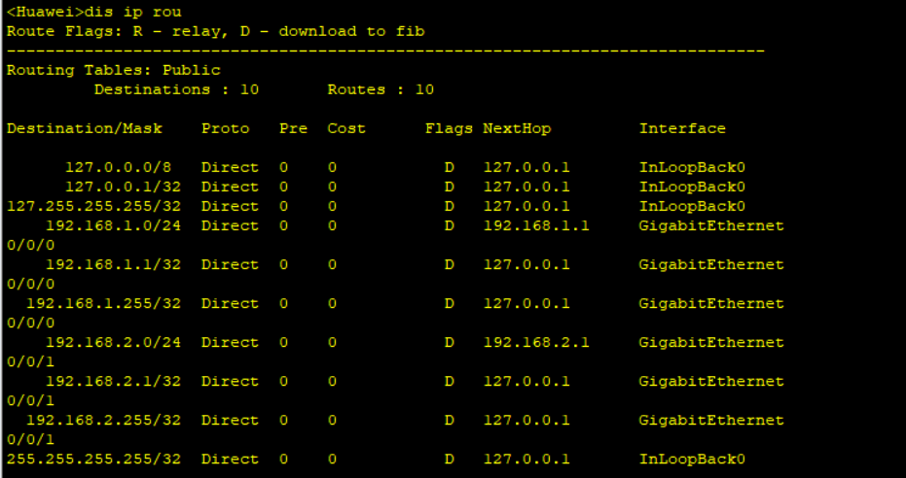

**So we can’t find Network 3 yet, let’s add network 192.168.3.0 to Router1 routing table.**

**From router1**

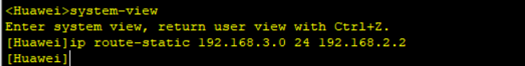

**Now let’s ping from PC1 to PC3**

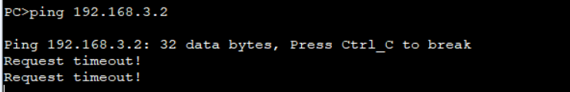

**Still we don’t get response of ping from PC3, because ping gives success response when it gets reply of it’s request. So let’s add network1 to routing table of router2**

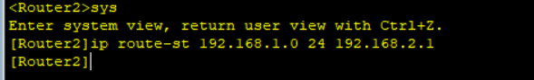

**Now let’s ping again from PC3 to PC2**

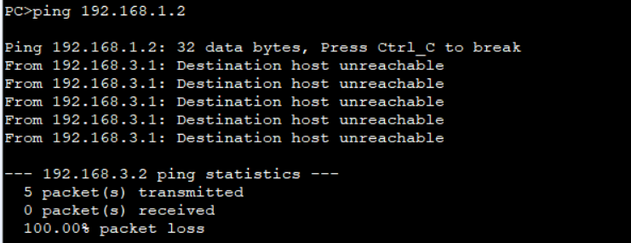

**And Now we have successfully connected 2 network interfaces.**

**Create 5 networks using static routing**

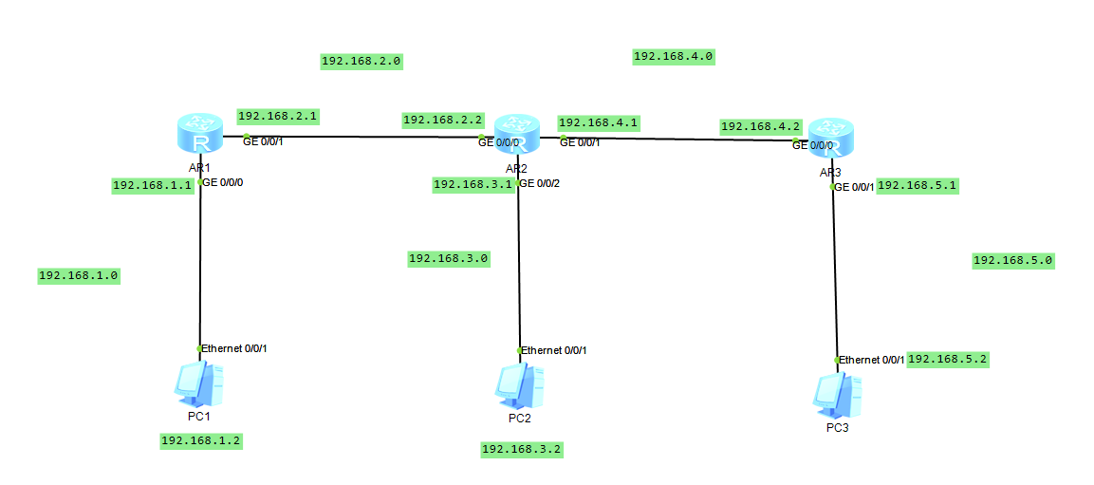

***Configure PC1, PC2, PC3 and Router1, router2 and Router3***

Ping from PC1 to its gateway

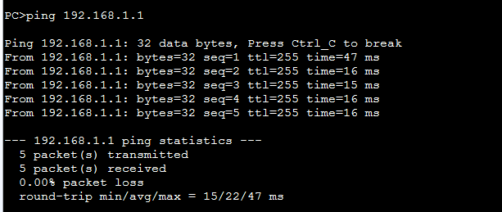

Ping from PC1 to 192.168.2.1

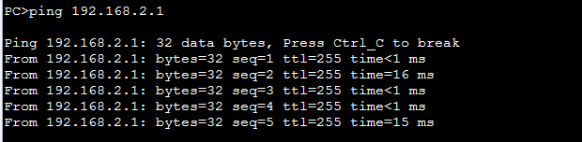

Ping from PC1 to 192.168.2.2

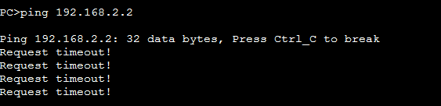

We see that Router2 is unknown to PC1 so as are network3, network 4 and network 5 and same goes to all PCS.

Ping from router1 192.168.2.2

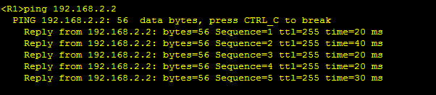

**Ping from router 1 to 192.168.3.1 and 192.168.4.1**

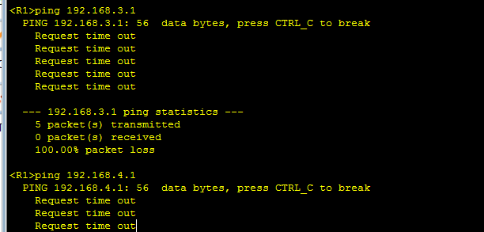

So we simply need to configure all Routers to send traffic from PC1 to PC2 and PC1 to PC3 etc

Let’s configure Router1

***First let’s check the routing table of router 1***

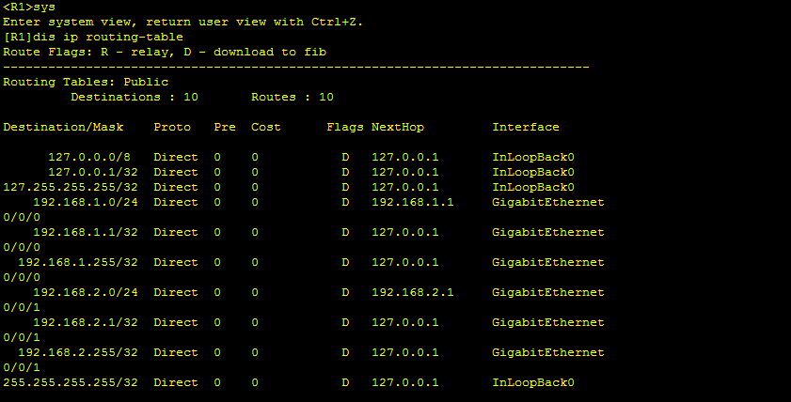

***We can’t find 192.168.3.0 as destination from Router1***

***So we add the network to router 1***



**Network 3 is added to router1 via 192.168.2.2 gate**

The message sent from Router1 will enter in network 3 via 192.168.2.2

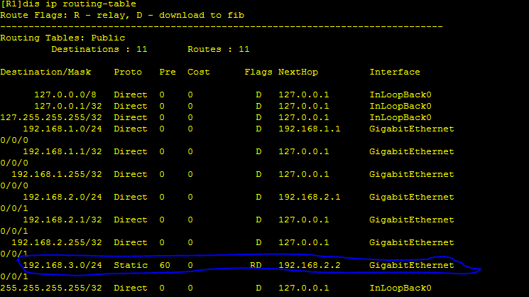

***Now let’s ping from PC1 to PC2***

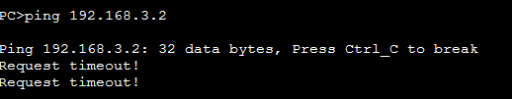

***Still Router2 can’t send reply to router1, so ping request is failed.***

Let’s configure Router2

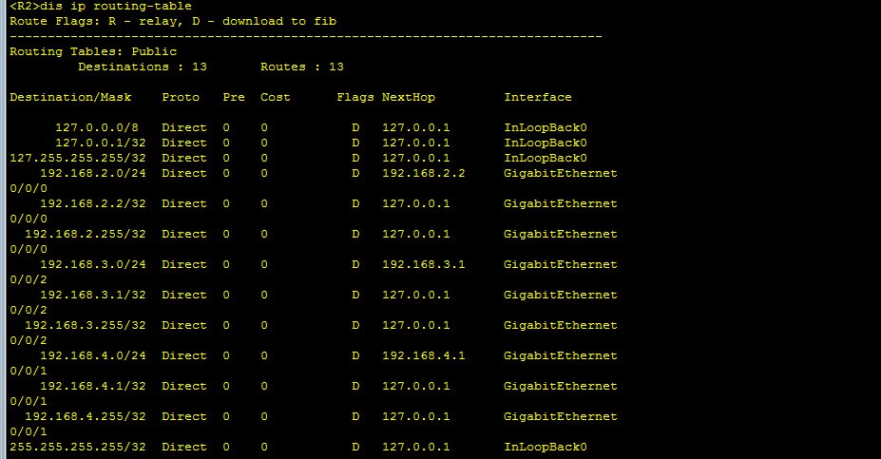

We can’t find Network 192.168.1.0 here, let’s add that to destination address of router2

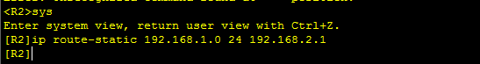

***Let’s again ping From PC1 to PC2***

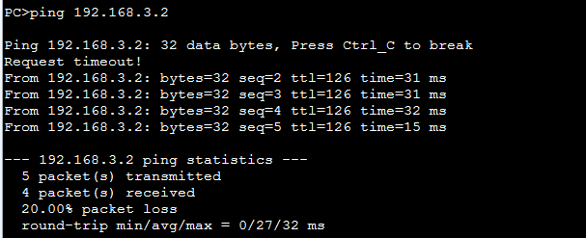

**Now network 1, network2 and network3 are configured and can send messages to each other.**

Now we configure From router1 to network4 and network5

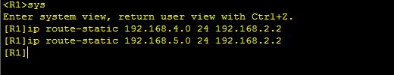

Now we configure From router2 to network5

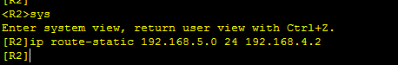

Now we configure From router3 to network1 and network3

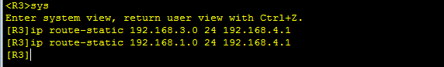

**Now we ping from PC1 on network1 to PC3 which is on network 5**

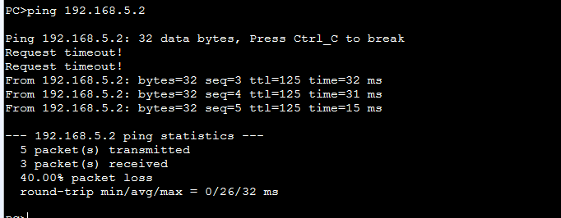

**So we finally configured all routers and built network of 5 networks and we call it inter networking.**

**How to know if all networks are connected to each other?**

**We can see from routing table of each router by looking at Destinations**

**On Router1**

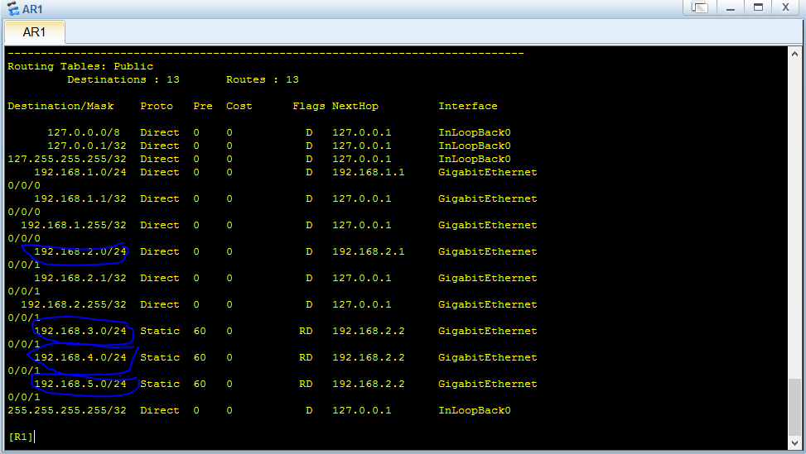

**On Router2**

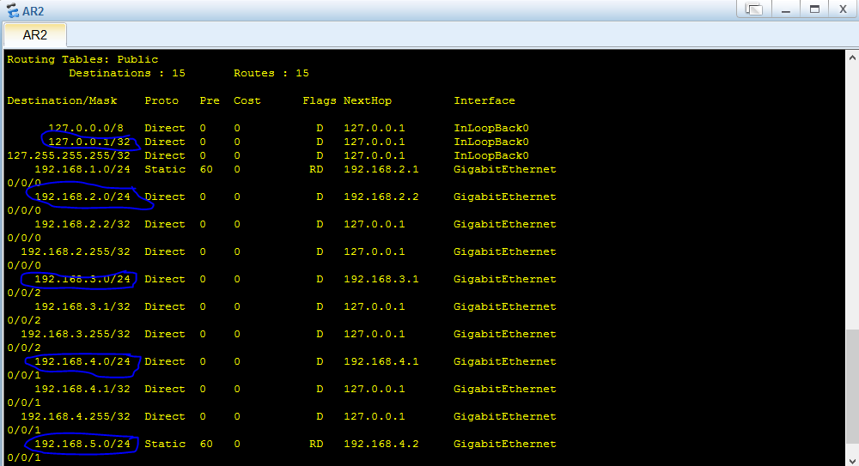

**On router3**

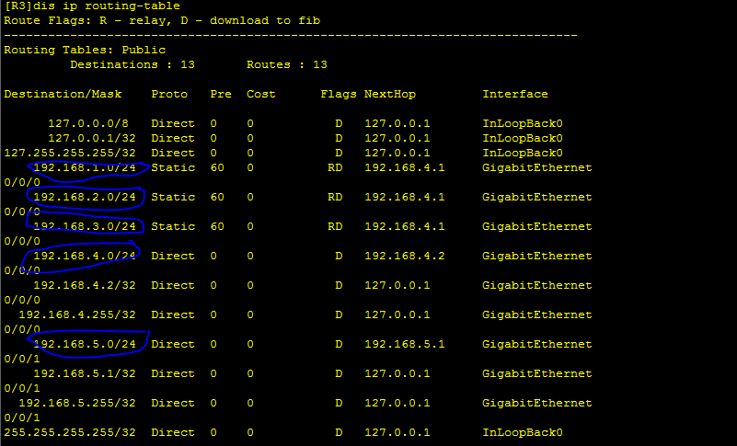

**Understand the routing table**

**We interpret each column**

**Destination/Mask: *Represents the Connected networks to router***

**Proto: *Protocol, defines the protocol of connected network***

**Pre: *Preference, used to select routes to destination in external routing domains***

**Cost: *Number of routers to be crossed before reaching destination***

**NextHop: *Address of next router***

**Create network of 5 interfaces using Dynamic routing by OSPF protocol**

**OSPF: Open shorted path firs**

Used to perform dynamic routing, we don’t need to change network configuring every time when a router is changed or added or removed.

We need to remove/undo the statically added networks from each router before configuring ospf.

***We design network:***

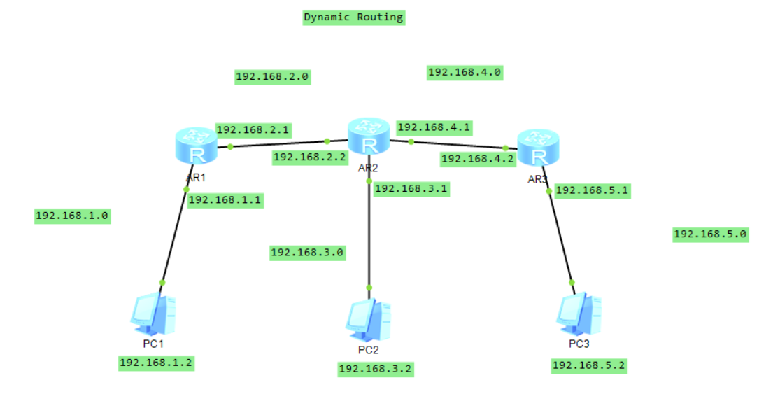

**Configure the PCs**

Exp for PC3

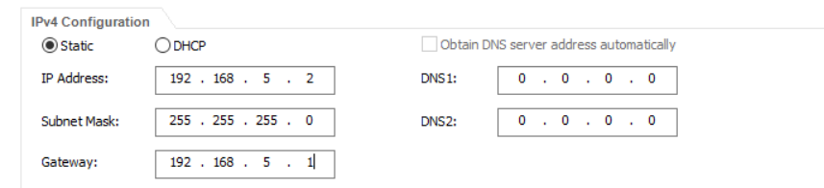

**Configure router1 by opsf**

**Net the directly connected networks**

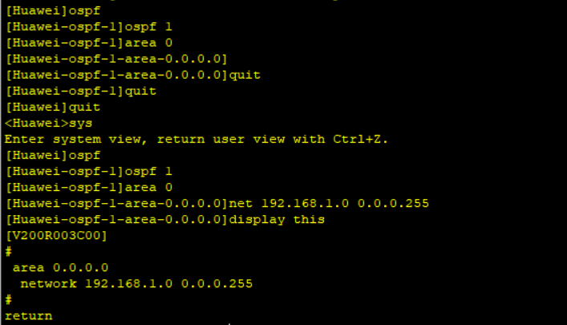

**192.168.1.0 is direct connected**

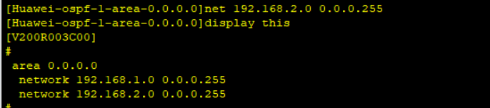

**192.168.2.0 is also directly connected network to Router1**

**Now configure Router2**

**Net all direct networks**

**192.168.2.0, 192.168.3.0 and 192.168.4.0 are directly connected.**

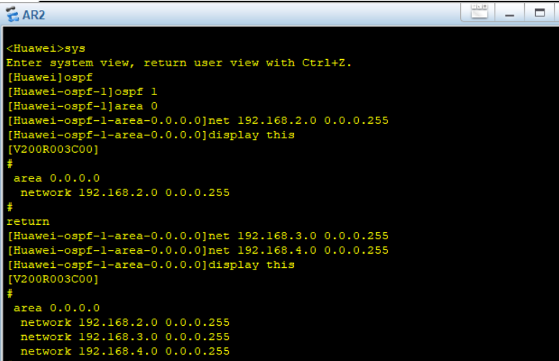

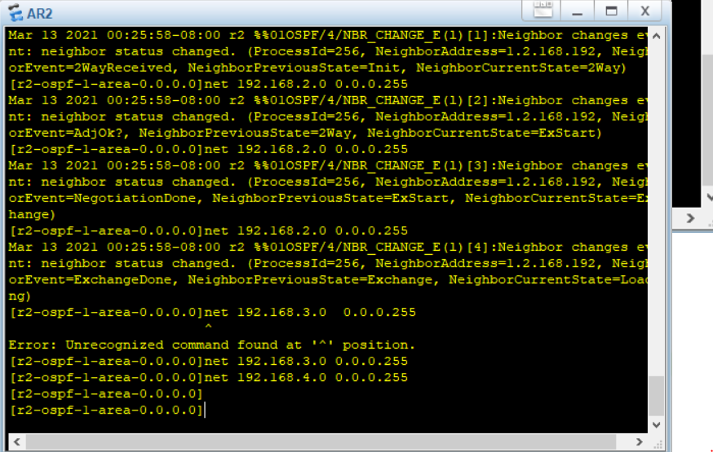**We also observed while configuring Router2**

**Now do same for router3**

**192.168.4.0 and 192.168.5.0 are direct networks of router3**

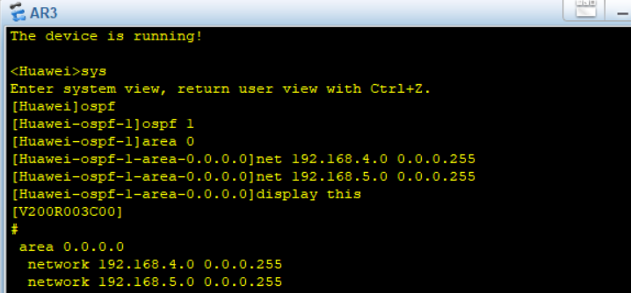

**Now we display routing table of each router and perform ping to test network**

**Routing table of Router1**

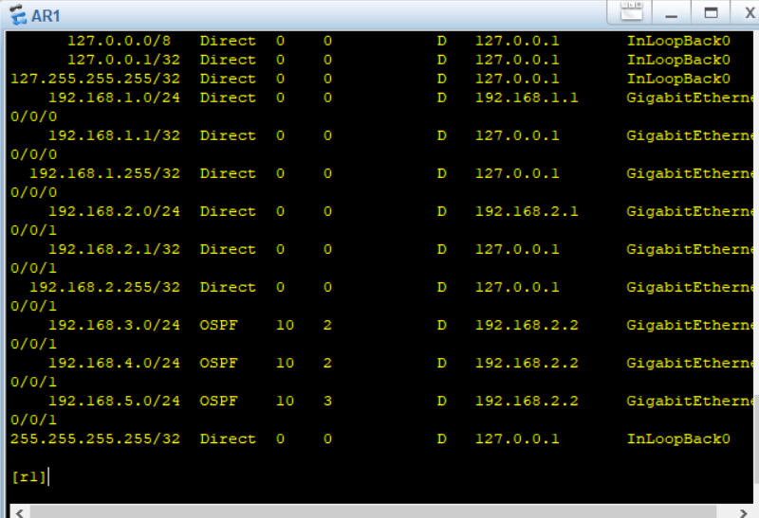

**Routing table of Router2**

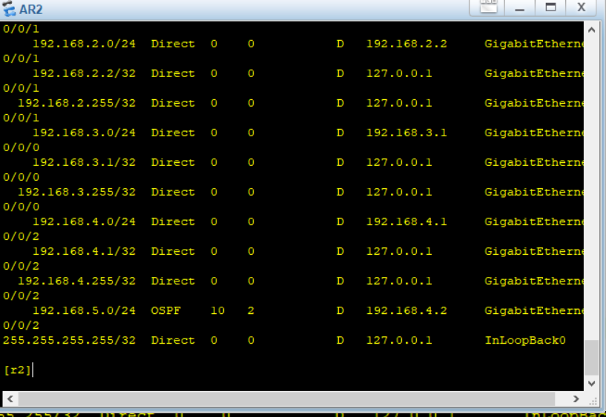

**Routing table of Router3**

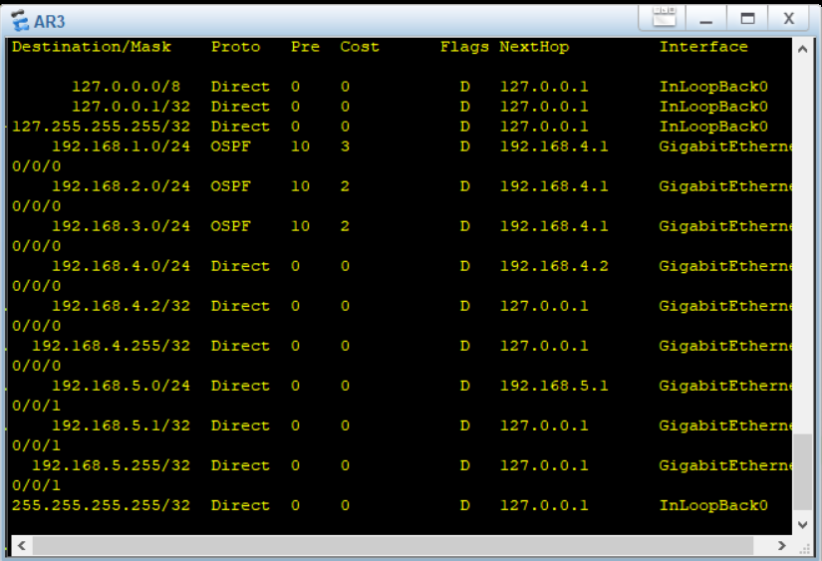

**Now We ping from PC1 to PC2**

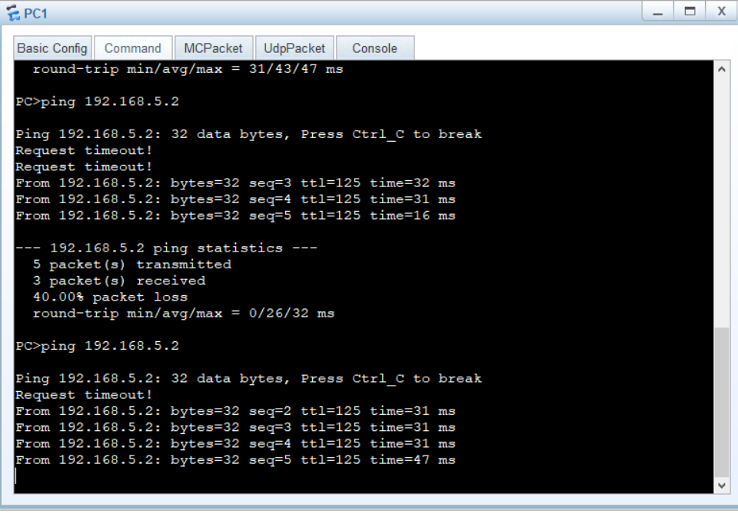

**The End**